

DUAL POLARIZED ANTENNA ARRAY FOR 5G MASSIVE MIMO SYSTEM

# A MINOR PROJECT-IV REPORT

***Submitted by***

SUGUMAR S (19BEC4210)

SURIYA R (19BEC4214)

VISHNURAM S (19BEC4235) YOGANATHAN M (19BEC4240)

**BACHELOR OF ENGINEERING**

in

**DEPARTMENT OF ELECTRONICS AND COMMUNICATION ENGINEERING**

**M.KUMARASAMY COLLEGE OF ENGINEERING**

(Autonomous)

**KARUR – 639 113**

**MAY 2022**

M.KUMARASAMY COLLEGE OF ENGINEERING, KARUR

**BONAFIDE CERTIFICATE**

**Certified that this project report “DUAL POLARIZED ANTENNA ARRAY FOR 5G MASSIVE MIMO SYSTEM” is the bonafide work of** “**SUGUMAR S (19BEC4210),SURIYA R (19BEC4214), VISHNURAM S (19BEC4235) YOGANATHAN M(19BEC4240)”****who carried out the project work under my supervision in the academic year 2021-2022.**

**SIGNATURE SIGNATURE**

Dr.S.JEGADEESAN, M.E., Ph.D., Mr.P.T.SIVAGURUNATHAN, M.E.,(Ph.D).,

**HEAD OF THE DEPARTMENT, SUPERVISOR,**

Assistant Professor, Assistant Professor,

Department of Electronics and Department of Electronics and

Communication Engineering, Communication Engineering, M.Kumarasamy College of Engineering, M.Kumarasamy College of Engineering, Thalavapalayam, Karur-639113. Thalavapalayam, Karur-639113.

This Minor project-IV report has been submitted for the **18ECP106L – Minor Project-IV**

Review held at M.Kumarasamy College of Engineering, Karur on .

# PROJECT COORDINATOR

**INSTITUTION VISION AND MISSION**

**Vision of the Institution**

To emerge as a leader among the top institutions in the field of technical education

# Mission of the Institution

**M1:** Produce smart technocrats with empirical knowledge who can surmount the global challenges

**M2:** Create a diverse, fully engaged, learner-centric campus environment to provide quality education to the students

**M3:** Maintain mutually beneficial partnerships with our alumni, industry, and Professional associations Vision of the Department

# Vision of the Department

To empower the Electronics and Communication Engineering students with emerging technologies, professionalism, innovative research, and social responsibility.

# Mission of the Department

**M1:** Attain the academic excellence through innovative teaching learning process, research areas & laboratories and Consultancy projects.

**M2:** Inculcate the students in problem solving and lifelong learning ability.

**M3:** Provide entrepreneurial skills and leadership qualities.

**M4:** Render the technical knowledge and skills of faculty members.

# Program Educational Objectives (PEOs):

**PEO1: Core Competence:** Graduates will have a successful career in academia or industry associated with Electronics and Communication Engineering.

**PEO2: Professionalism:** Graduates will provide feasible solutions for the challenging problems through comprehensive research and innovation in the allied areas of Electronics and Communication Engineering.

**PEO3: Lifelong Learning:** Graduates will contribute to the social needs through lifelong learning, practicing professional ethics and leadership quality

# Program Outcomes (POs):

**PO 1: Engineering knowledge:** Apply the knowledge of mathematics, science, engineering fundamentals, and an engineering specialization to the solution of complex engineering problems.

**PO 2: Problem analysis:** Identify, formulate, review research literature, and analyze complex engineering problems reaching substantiated conclusions using first principles of mathematics, natural sciences, and engineering sciences.

**PO 3: Design/development of solutions:** Design solutions for complex engineering problems and design system components or processes that meet the specified needs with appropriate consideration for the public health and safety, and the cultural, societal, and environmental considerations.

**PO 4: Conduct investigations of complex problems:** Use research-based knowledge and research methods including design of experiments, analysis and interpretation of data, and synthesis of the information to provide valid conclusions.

**PO 5: Modern tool usage:** Create, select, and apply appropriate techniques, resources, and modern engineering and IT tools including prediction and modeling to complex engineering activities with an understanding of the limitations.

**PO 6: The engineer and society:** Apply reasoning informed by the contextual knowledge to assess societal, health, safety, legal and cultural issues, and the consequent responsibilities relevant to the professional engineering practice.

**PO 7: Environment and sustainability:** Understand the impact of the professional engineering solutions in societal and environmental contexts, anddemonstrate the knowledge of, and need for sustainable development.

**PO 8: Ethics:** Apply ethical principles and commit to professional ethics and responsibilities and norms of the engineering practice.

**PO 9: Individual and teamwork:** Function effectively as an individual, and as a member or leader in diverse teams, and in multidisciplinary settings.

**PO 10: Communication:** Communicate effectively on complex engineering activities with the engineering community and with society at large, such as, being able to comprehend and write effective reports and design documentation, make effective presentations, and give and receive clear instructions.

**PO 11: Project management and finance:** Demonstrate knowledge and understanding of the engineering and management principles and apply these to one’s own work, as a member and leader in a team, to manage projects and in multidisciplinary environments.

**PO 12: Life-long learning:** Recognize the need for and have the preparation and ability to engage in independent and life-long learning in the broadest context of technological change.

# Program Specific Outcomes(PSOs):

**PSO1:** Applying knowledge in various areas, like Electronics, Communications, Signal processing, VLSI, Embedded systems etc., in the design and implementation of Engineering application.

**PSO2:** Able to solve complex problems in Electronics and Communication Engineering with analytical and managerial skills either independently or in team using latest hardware and software tools to fulfil the industrial expectations.

|  |  |
| --- | --- |
| **Abstract** | **Matching with POs, PSOs** |
| Antenna, Mutual coupling, Feeding network,Wilkinson power divider, Return loss, Massive mimo system | PO1, PO2, PO3,PO6,PO5,PO9,PO10, PO11,PO12,PSO1,PSO2 |

# ABSTRACT

Massive MIMO is a most promising technology to enhance for future wireless networks. The Massive MIMO with large antenna arrays at the base stations to have simultaneously served more users at a time via “Spatial Multiplexing”. In this project, we have proposed compact dual polarized antenna with four radiating square patches is presented. The proposed antenna designed for operating at 3.3 GHz frequency (Sub-6 GHz 5G band). This dual polarized antenna for small cell base station and portable wireless handset applications with fixed physical size and beneficial due to the higher array gain. It is obtained by twice the number of antennas in a single element. This design helps to satisfy the area throughput and channel capacity requirements 5G networks.The main challenges are to reduce the mutual coupling between the antenna elements in MIMO systems. This is due to the finite spacing between the antenna elements. Through the phase difference between the waves transmitted by the individual radiators, constructive and destructive interference is produced, and this phase difference is dependent upon the spacing between the radiators. The gain of the antenna is proportional to the number of elements, but the coupling between elements increases with increasing numbers of elements. This leads to a low data rate and high coupling coefficient. The next challenge is to maintain the isolation between antenna elements, since antenna elements are strongly coupled to one another.

# Table of Contents

|  |  |  |  |
| --- | --- | --- | --- |
| **Chapter**  **No.** |  | **Particulars** | **Page**  **No.** |
|  | Vision and Mission of the Institute and Department | | 3 |
|  | POs, PSOs of the Department | | 4 |
|  | Mapping of project with POs and PSOs | | 6 |
|  | Abstract | | 7 |
|  | List of Figures | | 9 |
|  | Acronyms/List of Abbreviations | | 10 |
| **1** | **INTRODUCTION** | | **11** |
|  | 1.1 | Background | 12 |
|  | 1.2 | Problem Statement | 13 |
|  | 1.3 | Objectives | 13 |
| **2** | **LITERATURE REVIEW** | | **14** |
| **3** | **FEASIBILITY STUDY** | | **16** |
| **4** | **PROJECT METHODOLOGY** | | **17** |
|  | 4.1 | Existing Method | 17 |
|  | 4.2 | Proposed Method | 17 |
| **5** | **RESULTS AND DISCUSSION** | | **18** |
| **6** | **CONCLUSION** | | **22** |
|  | **REFERENCES**  **OUTCOMES** | | **23**  **24** |

**LIST OF FIGURES**

|  |  |  |
| --- | --- | --- |
| **FIGURE No.** | **TITLE** | **PAGE No.** |
| 5.1 | Design | 18 |
| 5.2 | Layers | 19 |
| 5.3 | Return Loss | 20 |
| 5.4  5.5 | 3D plot view  VSWR Plot | 21  21 |

# LIST OF ABBREVIATIONS

|  |  |
| --- | --- |
| **ACRONYMS** | **ABBREVIATIONS** |
| HFSS | High Frequency Structure Simulator |
| MIMO | Multiple Input Multiple Output |
| DB | Decibel |
| RF | Radio Frequency |

**CHAPTER 1**

**INTRODUCTION**

Dual polarized antennas are able to improve the capacity and coverage that can be achieved with a wireless network. Antenna arrays naturally become the key role for Massive MIMO. In order to employ the numerous number of antenna elements efficiently in space as well as maintain the required performance. In our case Massive MIMO (Multiple Input Multiple Output) technology can provide dramatically increase in communication capacity, because energy can be focused with extreme sharpness into small regions in space, resulting from the aggressive spatial multiplexing used in massive MIMO with hundreds of antennas. It is still very challenging to optimize quantity and volume of the antenna array, especially in the applications with longer wavelength. The 3.7GHz band has been a popular choice for TD LTE (Long Term Evolution) system, therefore it could give better result in massive MIMO technology. The whole array can generate 18 bore sight beams with a gain of 16.6dB evenly distributed around the circumference. With the advantage of the antenna structure, the maximum mutual coupling between any two ports in the array is less than -29 dB across the operating frequency bands. The 3.7GHz band has been a popular choice for TD LTE(Long Term Evolution) system, therefore it would be a good frequency to test the massive MIMO technology. This paper presents a compact dual-polarized antenna with four radiating square patches and an array configuration like Turning Torso of three stacked orthohexagonal rings within a volume of 648mm×648mm×258mm (about 8λ×8λ×3λ, where λ is the wavelength in free space). The whole array can generate 18 boresight beams with a gain of 16.6dB evenly distributed around the circumference. With the advantage of the antenna structure, the maximum mutual coupling between any two ports in the array is less than -29 dB across the operating frequency bands.

# Background

The proposed antenna has seven layers. In the first layer consist of patches and second layer consist of dielectric layer and third one has the metallic coupling strips then 4th one has the dielectric and 5, 6,7th having the ground plane, dielectric and feeding network. The feeding network consists of two Wilkinson power splitters. The power is transferred from ports 1 and 2 to the coupling strips. Bow-tie apertures are located on the ground plane of Layer 5. Each pair of coupling strips and aperture functions as a balun through capacitive coupling at both ends, it can drive two radiating patches overlapped with each other. The power coming from port -1 divided into two equal ones to excite the horizontal (along the x-axis) in-phase current on all patches and vice versa. So horizontal and vertical polarization mode created independently by port 1 and port 2.

Massive MIMO can provide enhanced broadband services in the future, as well as more. There is no doubt that 5G networks will support a wide range of wireless services from infotainment to healthcare, smart cities and homes, manufacturing, and many others. Massive MIMO technology can be adapted to support a large number of Massive Machine Type Communication (MTC) devices. In addition, it is an excellent candidate to implement Ultra Reliable Communication as it can establish extremely robust physical links.

# Problem Statement

The main challenges are to reduce the mutual coupling between the antenna elements in MIMO systems. This is due to the finite spacing between the antenna elements. Through the phase difference between the waves transmitted by the individual radiators, constructive and destructive interference is produced, and this phase difference is dependent upon the spacing between the radiators. The gain of the antenna is proportional to the number of elements, but the coupling between elements increases with increasing numbers of elements. This leads to a low data rate and high coupling coefficient. The next challenge is to maintain the isolation between antenna elements, since antenna elements are strongly coupled to one another.

# Objectives

One of the major benefits of a dual-polarized transmit-array is reduction of transmit-array size by half compared to a spatially separate single-polarized transmit-array. Since two co-located orthogonal transmit-antennas are installed on a co-located dual-polarized antenna, a double number of transmit- antennas can be installed compared to a spatially separate single-polarized transmit-array for identical size of the transmit-array. The degrees of freedom of a dual-polarized transmit-array can achieve twice the performance compared to a conventional single-polarized transmit-array for identical size of the transmit-array.

# CHAPTER 2

# LITERATURE REVIEW

In the late on the 2000s, the fourth generation (4G) mobile system was introduced and was all Internet Protocol (IP) which based network system. It aims to provide high capacity, high quality, security, high speed and low-cost services for voice and data services, multimedia and internet over IP. As a result, for huge growth of devices number which demanding internet-access that would require wide bandwidth in order to operate in normal state that 4G cannot cut it anymore, therefore fifth-generation (5G) have been introduced. It is critical issue in term of speed, response time, energy efficiency and network reliability. The high frequencies concerned with short wavelengths, and for millimeter waves which have range of 1 mm to 10 mm. 5G is being related to the use of millimetre-wave by allocating more bandwidth to arrive faster with higher quality video and contain multimedia and services.Nowadays almost every specification for 5G device states dual-polarization as a basic and mandatory feature. Dual-polarized antennas became a part of everyday work for most RF engineers, but mmWave frequencies add even more challenges to it. To separate channels from each other and allow sending data through both channels working on one frequency without interfering. each polarization has its own feed, so when one feed is excited, another one is passive. In the late on the 2000s, the fourth generation (4G) mobile system was introduced and was all Internet Protocol (IP) which based network system. It aims to provide high capacity, high quality, security, high speed and low-cost services for voice and data services, multimedia and internet over IP. As a result, for huge growth of devices number which demanding internet-access that would require wide bandwidth in order to operate in normal state that 4G cannot cut it anymore, therefore fifth-generation (5G) have been introduced. It is critical issue in term of speed, response time, energy efficiency and network reliability.

Other public health actions that are used to limit the spread of an infectious disease include isolation and quarantine. Isolation is used when a person is sick and has a contagious infection. The sick person is separated from people who are not sick. People who are isolated may be cared for in hospitals, other healthcare facilities and in their own homes. In most cases isolation is voluntary, but federal, state and local health officials have the power to require the isolation of sick people to protect the general public’s health. When a person is placed in quarantine, they are also separated from others. Even though the person is not sick at the moment, they were exposed to a contagious disease, may still become infectious and then spread the disease to others. Other quarantine measures include restricting travel of those who have been exposed to a contagious disease, and restrictions on people coming or going into a specific area. States have the power to enforce quarantines within their borders. Both isolation and quarantine may be used by health officials during an influenza pandemic to help slow the spread of the disease.

# CHAPTER 3

# FEASIBILITY STUDY

Massive MIMO can provide enhanced broadband services in the future, as well as more. There is no doubt that 5G networks will support a wide range of wireless services from infotainment to healthcare, smart cities and homes, manufacturing, and many others. Massive MIMO technology can be adapted to support a large number of Massive Machine Type Communication (MTC) devices. In addition, it is an excellent candidate to implement Ultra Reliable Communication as it can establish extremely robust physical links.

The proposed antenna has seven layers. In the first layer consist of patches and second layer consist of dielectric layer and third one has the metallic coupling strips then 4th one has the dielectric and 5, 6,7th having the ground plane, dielectric and feeding network. The feeding network consists of two Wilkinson power splitters. The power is transferred from ports 1 and 2 to the coupling strips. Bow-tie apertures are located on the ground plane of Layer 5. Each pair of coupling strips and aperture functions as a balun through capacitive coupling at both ends, it can drive two radiating patches overlapped with each other. The power coming from port -1 divided into two equal ones to excite the horizontal (along the x-axis) in-phase current on all patches and vice versa. So horizontal and vertical polarization mode created independently by port 1 and port 2.

# CHAPTER 4

# PROJECT METHODOLOGY

* 1. **Existing Method**

Nowadays almost every specification for 5G device states dual-polarization as a basic and mandatory feature. Dual-polarized antennas became a part of everyday work for most RF engineers, but mmWave frequencies add even more challenges to it. he long version of this answer includes some basics of MIMO (Multiple Input Multiple Output) technologies. As was mentioned above, each polarization is fed separately, so the device can transmit two data streams. From the receiver’s point of view, the signal is interpreted as two discrete streams. The easiest and most popular MIMO configuration is 2X2 MIMO, with transmitter and receiver working across orthogonal polarizations. This approach also allows avoiding using two separate arrays for the same working capacity, which results in saving space and reducing manufacturing costs.

# Proposed Method

Multi-user multiple-input multiple-output (MU-MIMO) system for smartphone applications has drawn many attentions. Its good performances to improve the data rate make it one of the core technologies for 5G communication. However, the limited spaces provided by a smartphone make it very difficult to embed more antennas. Isolations will dramatically deteriorate when antenna units are closely placed. Thus, how to embed more antennas within the smartphone becomes a great challenge for designers. Recent years, some MIMO antenna arrays have been proposed [2]- [4], but the long edges of the phone are more or less occupied, their demands for clearance on the long edges can’t meet the requirement for narrow frame.

# CHAPTER 5

# RESULTS AND DISCUSSION

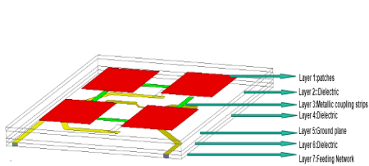

Fig: 5.1 design

1. **Components used:**
2. Layers
3. Graph
4. 3D plot view
5. VSWR

## 1.LAYERS

**LAYER 1 LAYER 2**

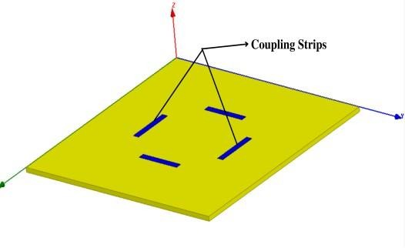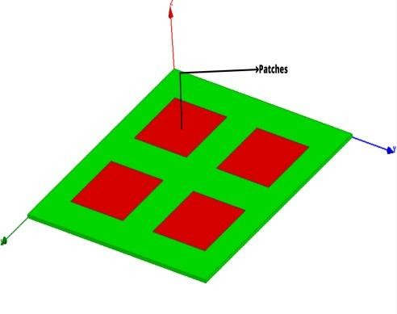

Radiating Patches Metallic Coupling Strips

## 

## LAYER 3 LAYER 4

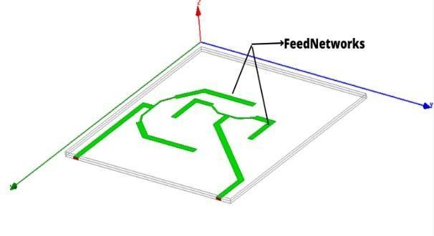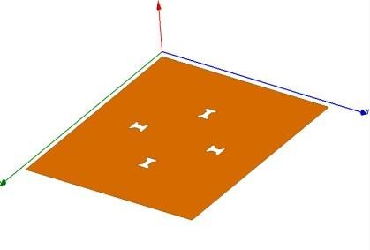

Bow-tie Network Feeding Networks

Fig: 5.2 Layers

## GRAPH

The proposed antenna is simulated, optimized and parametric studied using High Frequency Structure Simulator (HFSS) software. From the results it is concluded that the proposed antenna can be used for massive MIMO Communication Systems. The following plots show overall results of proposed antenna.

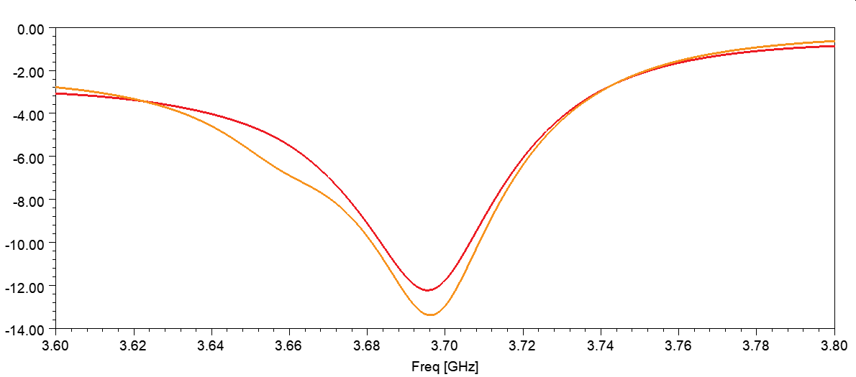

Fig: 5.3 Return loss

## 3.3D PLOT

For the base station of massive MIMO system, the arrayconfiguration is similar to the Turning Torso building, and is a three stacked levels of orthohexagonal wall rings with a progressive twisting angle of 20° between adjacent levels. Each ring is composed of six antenna sub-arrays, which is a linear array with four proposed antenna units, resulting in 16 patches and 8 ports per sub-array.Therefore, there are 18 sub-arrays distributed around the whole circumference to provide 18 independent beams with included angle of 20° between adjacent boresight. Compared with the configuration in paper, the stacked one can reduce the radial size of the ring by increasing the longitudinal size of the stack.

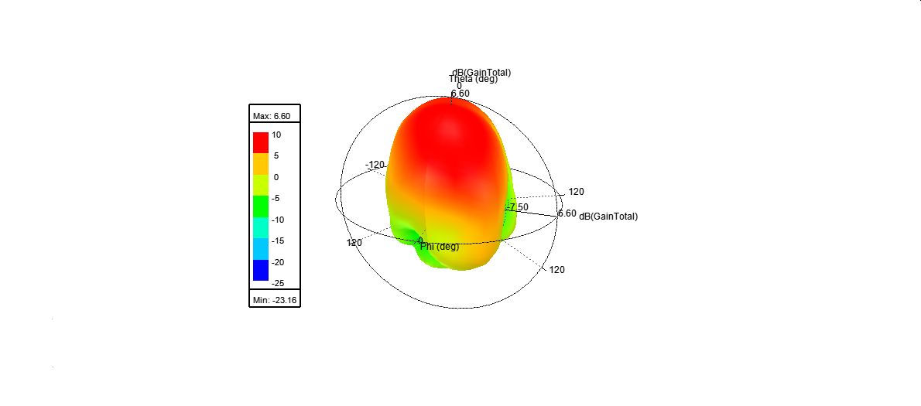

Fig: 5.4 3D Plot

1. **VSWR PLOT**

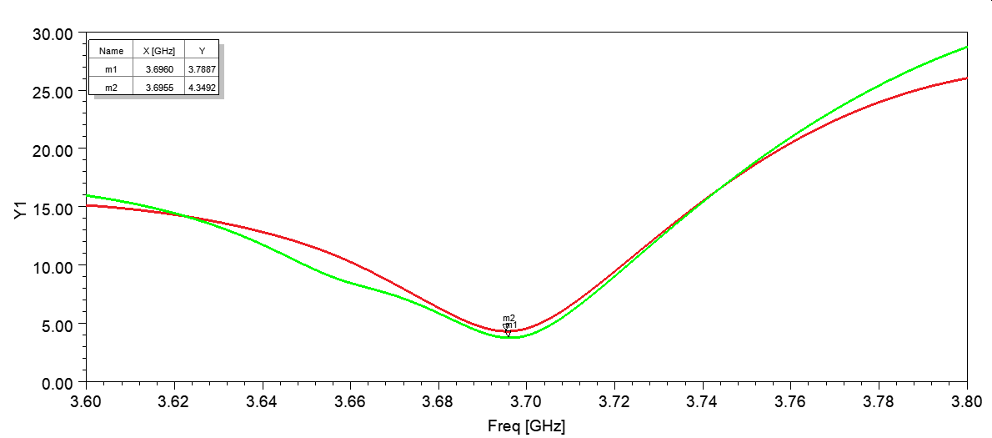

Fig: 5.5 VSWR Plot

# CHAPTER 6

# CONCLUSION

A compact dual-polarized antenna with four radiating square patches is presented. An array configuration containing 18 sub-arrays with four such antenna elements is also demonstrated. With the short distance between the adjacent patches and the stack configuration, the antenna array only occupies a volume of about 8λ×8λ×3λ when the maximum mutual coupling between any two ports is less than - 29dB. With the beams narrow in azimuth and broad in altitude, the demonstrated array is very suitable for the small cell base station deployed in the urban area with high-density buildings

# REFERENCES

.

1. E. Larsson, O. Edfors, F. Tufvesson, and T. Marzetta, “Massive MIMO for next generation wireless systems,” IEEE Communications Magazine, vol. 52, pp. 186-195, 2014.
2. Y.Zeng, R. Zhang, and Z. N. Chen, “Electromagnetic Lens-Focusing Antenna Enabled Massive MIMO: Performance Improvement and Cost Reduction,” IEEE J. Selected Areas in Communications, vol. 32, pp 1194-1206, 2014.
3. I. Tzanidis, B. Loong Ng, Y. Li, Y.-H. Nam, G. Xu, J. Zhang,Y. Kim and J. Lee, “Patch Antenna Array Configuration for Application in FD MIMO Systems,” IEEE Antennas and Propag. Society International Symp., Orlando, FL, USA, pp. 2241-2242, 2013.
4. R. Ma, Y. Gao, L. Cuthbert, and Q. Zeng, “Antipodal Linearly Tapered Slot Antenna Array for Millimeter- wave Base Station in Massive MIMO Systems,” IEEE Antennas and Propag. Society International Symp., Memphis, TN, USA, pp. 1121-1122, 2014.
5. T. Nakamura, “LTE Release 12 and Beyond,” LTE Africa 2013, 3GPP, pp. 15, 2013.

# OUTCOMES

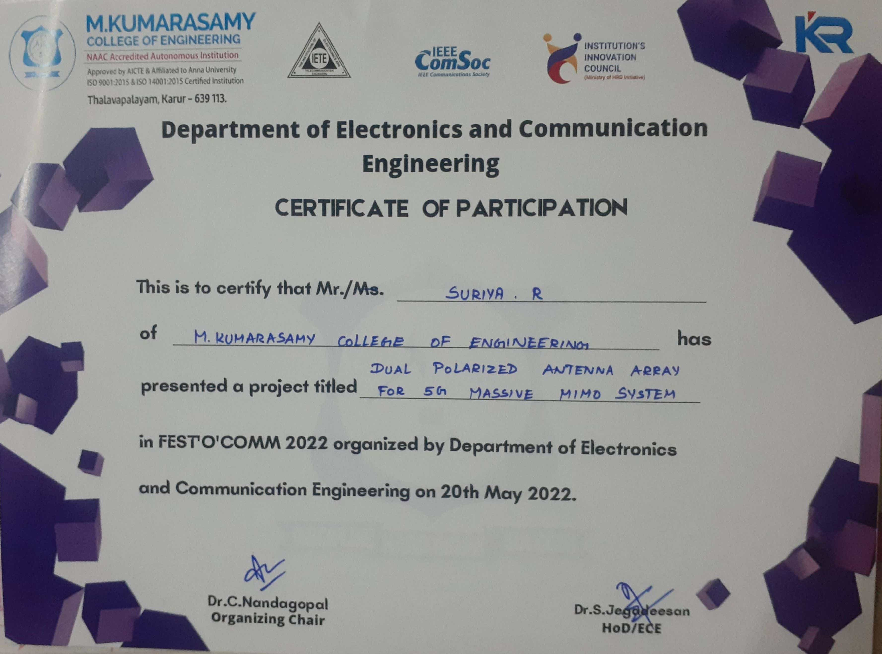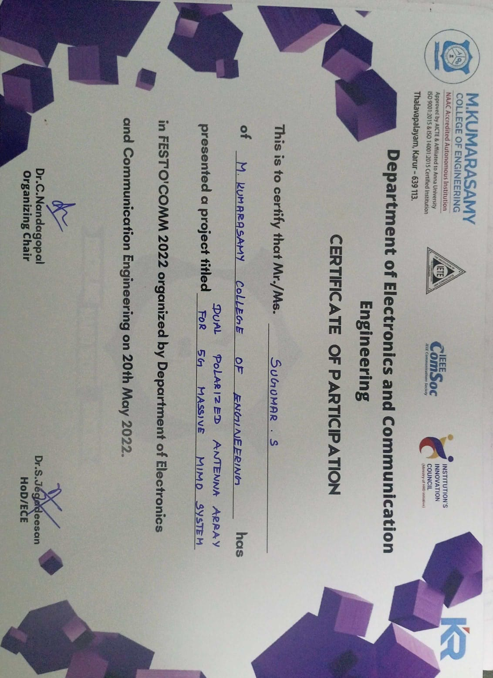

24

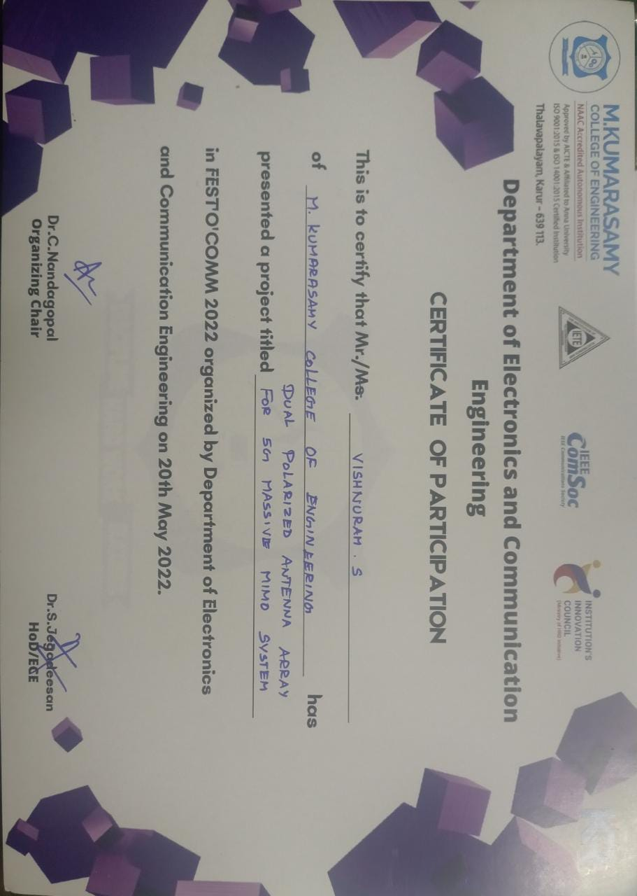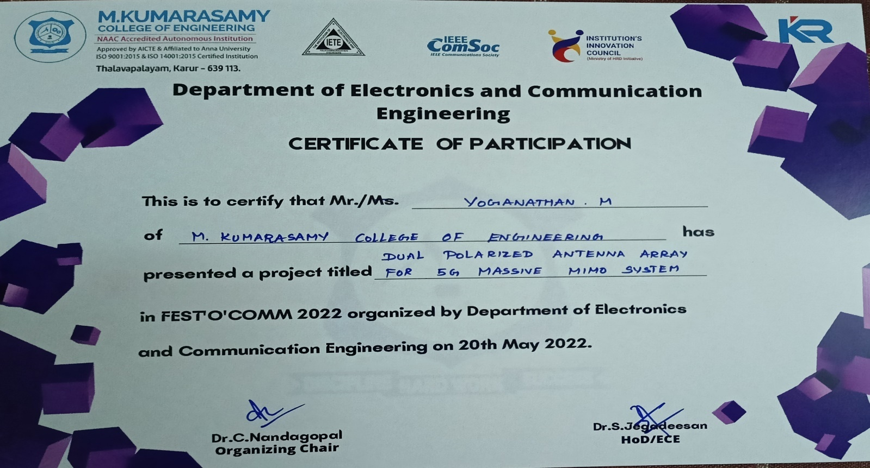

25